1 – Using “WebStorm” local server



2 – Using “Web Server for Chrome”

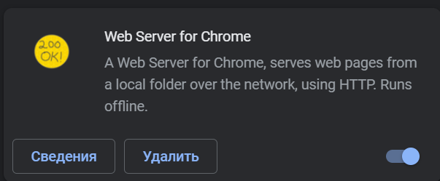

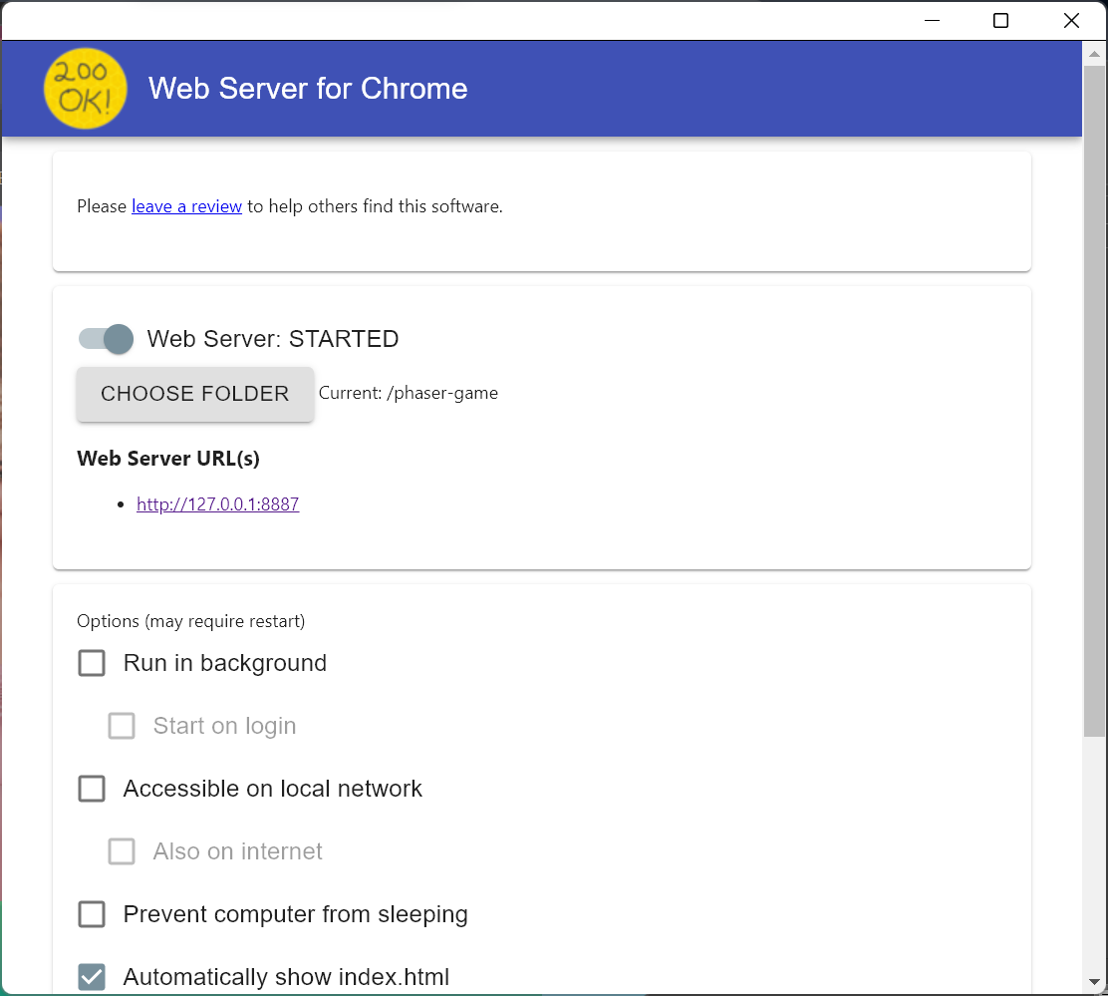

! path must point to the folder with game